🏙️ WATERGARDEN RESIDENCES

Fort Lauderdale, Florida — The “Goldilocks” of Luxury Living
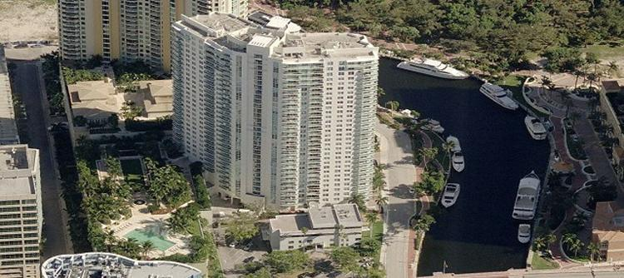
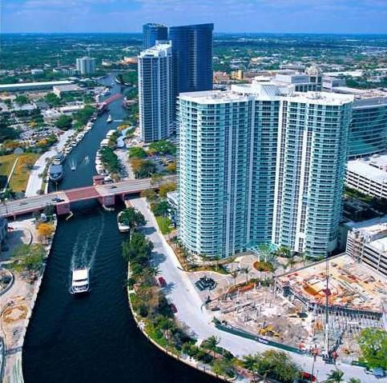
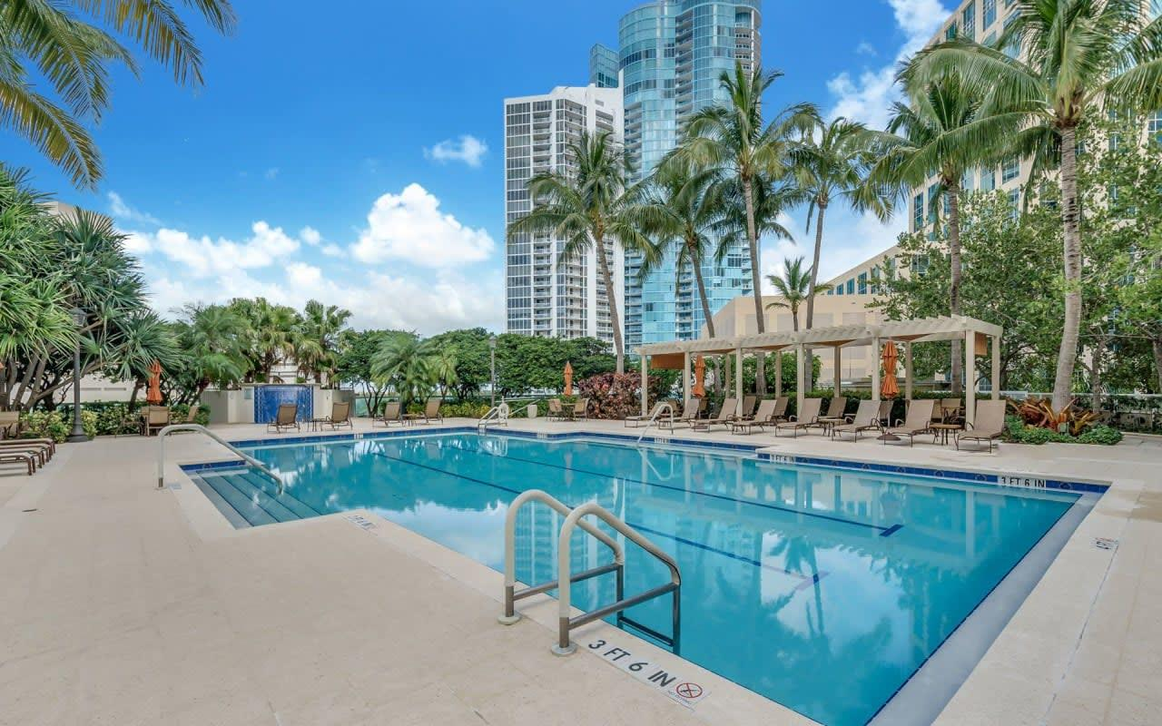
4

Executive Memo
The WaterGarden Residences occupy a uniquely enviable position in the Fort Lauderdale luxury market—perfectly situated between two of the city’s most prestigious towers: the iconic New River and Las Olas Grand.
At approximately 17 years of age, WaterGarden has matured into what many discerning buyers consider the “Goldilocks” opportunity—not too new (and priced at a premium), not too old—but just right in terms of value, location, pricing, and livability.

Why WaterGarden Stands Apart
✔ Prime Riverfront Location
Ideally positioned along the New River and Riverwalk, offering walkability to Las Olas Boulevard, dining, culture, and entertainment.
✔ Strong Value Proposition
Compared to newer construction towers commanding significant premiums, WaterGarden delivers luxury living at a more compelling price point, without sacrificing lifestyle or prestige.
✔ Established, Vibrant Community
WaterGarden is known for its welcoming, social, and engaged resident base—a true community rather than simply a building.
✔ Award-Winning Concierge & Lifestyle
A hallmark of the property is its exceptional concierge service, complemented by a robust calendar of social events, gatherings, and resident activities.

Governance & Financial Strength
✔ Highly Respected Board & Management
Ownership benefits from experienced leadership and professional management, contributing to a well-run and stable association.
✔ Strong Reserves
Financial stewardship is a key strength, with solid reserves providing confidence and long-term stability for owners.

Forward-Looking Enhancements
WaterGarden is not standing still—it is evolving.
Planned and ongoing improvements include:
- Lobby modernization
- Club room and theater refresh
- Boardroom upgrades
- Pool and outdoor enhancements
- Updated furnishings and aesthetic improvements throughout
These initiatives reflect a forward-thinking vision to elevate the property while preserving its established character and value.

Market Position
In today’s Fort Lauderdale market:
- New construction = premium pricing + extended timelines
- Older inventory = potential renovation costs and uncertainty
- WaterGarden = the ideal balance
A luxury residence with proven value, strong community, and continued enhancement—without the premium or the hassle.

Final Thought
WaterGarden is more than a condominium—it is a lifestyle-driven, community-oriented luxury residence that continues to gain appeal.
For buyers seeking location, value, stability, and social vibrancy, WaterGarden represents a rare and compelling opportunity.

